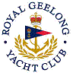 | Royal Geelong Yacht Club Inc.  Est 1859
Trophy Deed of Gift.

Trophy: | Charles (Chick) H. Fleet Perpetual Trophy
Presented by: | Chick Fleet (Snr) (Died 1976)
Date: | 1957
For: | Cadet Class: Most Improved Skipper
Remarks / Revisions | Was a pre-WW2 Secretary
Click here for Recipients
Charles Fleet was apprenticed to Hammerton & Son initially as a Gold Smith and later jewellers, taking over the business from Hammerton.
Hand-crafted the
- H P Douglas Shield
- Thacker Shield
- Possibly others

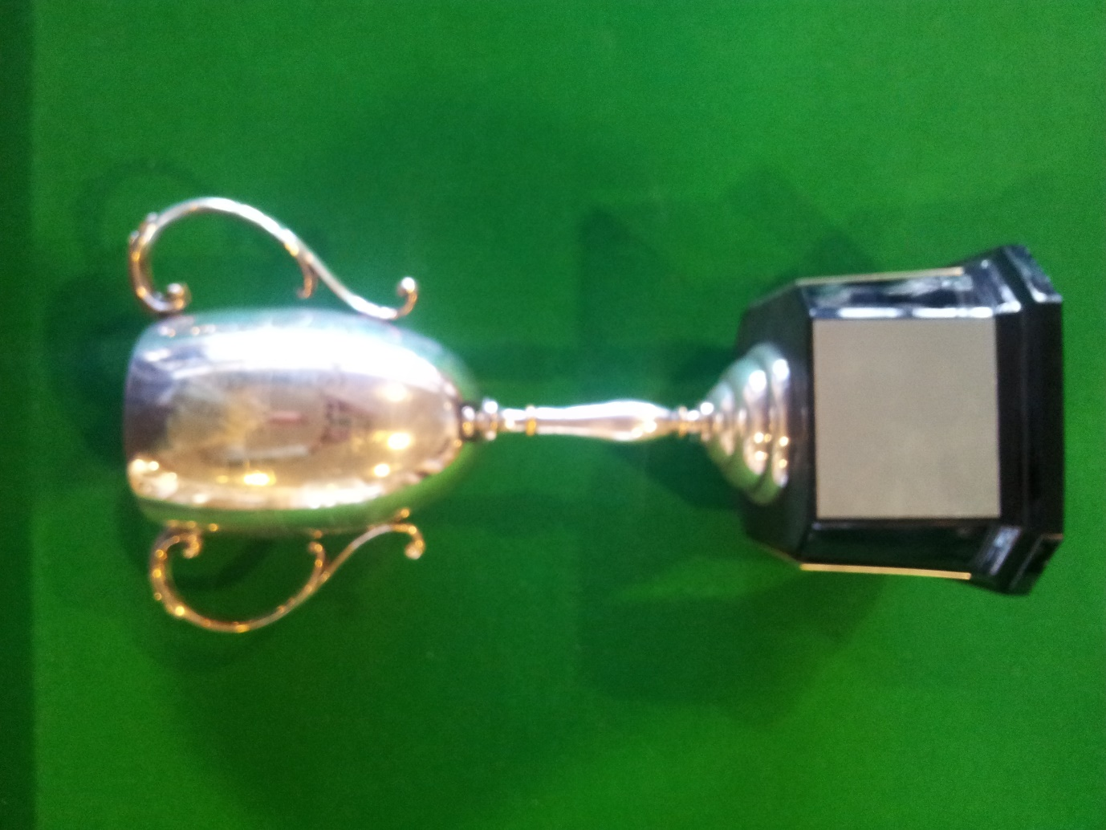

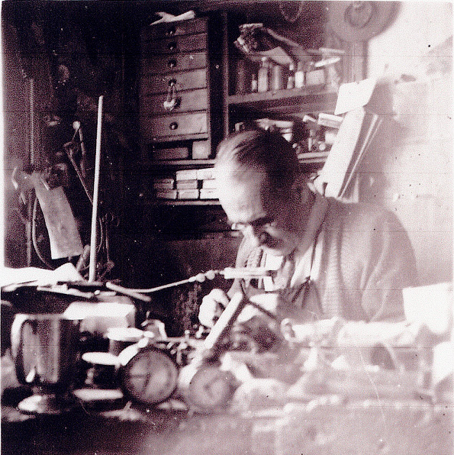

C. H. Fleet Snr
At Work

